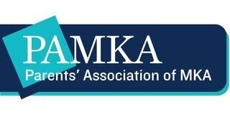

PAMKA’s Gifts to MKA 2019-2020

PAMKA is proud to announce the following gifts to Montclair Kimberley Academy:

TRI-CAMPUS

Supplemental Financial Aid and Assistance $ 300,000
Faculty Trust Grants* $ 0
Brookside Capital Campaign $ 10,000
MKA Lecture Series $ 15,000
Wish List** $ 10,000
Survival Shop $ 10,000

TOTAL GIFTS FOR 2019-2020 $ 345 ,000

* Faculty Trust Grant (FTG) recipients were unable to travel in 2020 due to COVID-19. Therefore, all FTG recipients will travel in 2021 with no additional Faculty Trust Grants being awarded in the 2020-2021 school year.

** The Wish List process, which primarily takes place in the spring, was disrupted due to COVID-19. Therefore, PAMKA’s Wish List gift will be administered at MKA’s discretion.

